Brain activity forecasts changing market demand for innovative vehicles

Brian Knutson¹, Dylan Christiano¹, Cynthia Wu¹, Tara Srirangarajan¹,
Nicole Deng¹, Matthew Klenk², Charlene Wu², Shabnam Hakimi²

Department of Psychology, Stanford University, Stanford CA 94305 ¹
Toyota Research Institute, Los Altos, CA 94022 ²

Draft (25.08.14): Please do not cite or distribute

To do:
Reformat for Science
Write cover letter

Contact: knutson@stanford.edu

Abstract:
Climate change has motivated innovation of new types of vehicles with sustainable features (e.g., electric powertrains). While brain activity has been used to forecast aggregate demand for diverse appeals and products, neuroforecasting has yet to address dynamic changes in market demand for large purchases with novel features. Here, we sought to use brain activity to forecast changes in United States market demand for vehicles with novel features (collected with Functional Magnetic Resonance Imaging or FMRI) in two separate samples over consecutive years (i.e., 2022 n=13, 2023 n=40). In both samples, activity in brain regions associated with anticipation of gain (i.e., the Nucleus Accumbens or NAcc) predicted individuals’ desire to know more about and purchase vehicles. Further, group NAcc activity repeatedly forecast changes in market demand for vehicles out of sample (i.e., 2022 k=24, 2023 k=30), while behavioral ratings did not. Behavioral ratings, however, were more associated with (or “backcast”) changes in market demand during the previous year. Together, these findings indicate that brain activity can forecast future changes in market demand for large purchases with novel features, while behavioral ratings instead appeared to backcast past changes in market demand. These findings have theoretical implications for refining the temporal specificity of neuroforecasting and practical implications for forecasting dynamic indices of demand for innovative products.

Key points:
1. Neuroforecasting researchers have yet to forecast changes in demand for large purchases with novel features (e.g., vehicle models).
2. In two studies combining behavioral tasks with neuroimaging, NAcc activity predicted individuals’ desire to know more about and purchase vehicles.
3. Group NAcc activity also forecast changes in demand for vehicles in the United States market.
4. Group behavioral ratings instead “backcast” changes in demand for vehicles during the previous year.
5. Findings support using neuroeconomic methods to forecast changing demand for large purchases with novel features.

Introduction
Based on growing concerns about environmental sustainability, demand for vehicles powered by alternative fuel sources has increased, leading to the innovation of new features (e.g., electric powertrains). Forecasting changes in market demand for novel products, however, presents a significant challenge, due to a lack of relevant historical data (Assmus, 1984; Goodwin et al., 2014). Models of product demand are traditionally constructed using retrospective sales data or behavioral measures such as self-report ratings and intentions to purchase (Armstrong et al., 2000; Morrison, D. G., 1979; Morwitz et al., 2007). These retrospective measures, however, may fail to forecast dynamic preference shifts associated with the introduction of products with innovative features.
Neuroeconomics research has revealed that brain activity can predict diverse purchasing decisions within individuals (Knutson et al., 2007; Levy & Glimcher, 2012). For instance, researchers have used brain activity in circuits associated with gain anticipation (Erk et al., 2002) and value integration (Tusche et al., 2010) to predict individual preferences for (but not purchasing of) different vehicles. While brain activity can predict individual purchases within individuals, it may or may not generalize to forecast demand for the same products out-of-sample in others (Knutson & Genevsky, 2018). Indeed, the ability of brain activity to forecast demand for large purchases out-of-sample has yet to be explored (Ariely & Berns, 2010). To address this challenge, we conducted two experiments that tested whether brain activity could not only predict preferences for vehicles with sustainable features within individuals but also forecast changes in market demand out-of-sample.
Recently developed “neuroforecasting” methods have further allowed researchers to track stages of choice processing and test whether they generalize to forecast market demand out-of-sample (Knutson & Genevsky, 2018). These forecasting methods might particularly add value in markets in which choices cannot incorporate previous experience or habits, including markets for emerging products with novel features (Genevsky et al., 2025). Thus, neuroforecasting methods might not only forecast average current demand but also changes in demand for products with novel features, even though they necessarily start from a baseline of no sales. Thus, neuroforecasting methods might especially add value when one seeks to forecast dynamic changes in future demand (in contrast to explaining past changes in demand, or “backcasting”) (Ebert et al., 2009; Robinson, 1982).
In this work, drawing from an Affect-Integration-Motivation (AIM) framework that identifies hierarchical neural predictors of individual choice (Samanez-Larkin & Knutson, 2015), we hypothesized that activity in the Nucleus Accumbens (NAcc) associated with gain anticipation, Anterior Insula (AIns, negatively) associated with loss anticipation, and Medial PreFrontal Cortex (MPFC) would predict individuals’ desire to purchase vehicles, including those with novel features. We further hypothesized that activity in the NAcc (positively) and possibly the AIns (negatively) would generalize out-of-sample to forecast annual changes in demand for those vehicles in the United States market, including those with novel features (i.e., electric versus gas powertrains; preregistered predictions at https://osf.io/xd9mk/).
This research thus aimed to bridge a gap between individual prediction and aggregate forecasting by examining whether brain activity could add value in a domain where behavioral forecasts may fall short (Armstrong et al., 2000). This approach demonstrates the potential of neuroforecasting to illuminate changes in demand for innovative products in general, and those with environmentally sustainable features in particular.

Methods
Overview: Individuals from two samples collected during consecutive years (2022 and 2023) viewed and evaluated available vehicle models. Quarterly vehicle model sales data in the United States were also collected to assess changes in sales (slope) over each year of data collection. Targeted brain data were then used to predict participants’ individual choices, as well as to forecast changes in aggregate United States market demand for different vehicle models (Supplementary Figure 1).

Participants: Individuals (2022 sample: 10 females, 6 males; ages 20-30 years; 2023 sample: 33 females, 26 males; ages 19–58 years) were recruited from Stanford University and the surrounding community. Potential participants expressed an intent to purchase a new vehicle within the upcoming three years. The first 2022 sample included 16 individuals (n=13 passed quality assurance checks) and was collected from February to September of 2022. The second 2023 sample was preregistered and included 59 individuals (n=40 passed identical quality assurance checks) and was collected from May to June of 2023. Participants were excluded from analysis who: (1) exhibited excessive head motion (>6 mm displacement in >5 % of volumes; n=3 in 2022, n=6 in 2023), (2) exhibited insufficient choice variability (chose “purchase” on <5 % or >95 % of trials; n=13 in 2023), (3) failed to respond on >20 % of the trials (n=3 in 2023), or (4) had a structural brain abnormality (n=1 in 2023) (Supplementary Figure 2). Participants received compensation of $20 per hour and the research was approved by the Stanford University Medical School Institutional Review Board.

Vehicle rating tasks: Visual stimuli depicted vehicles commercially available in the United States during each year of data collection. High-resolution photographs of each vehicle model were licensed from the EVOX Image Database (https://www.evoximages.com), standardized to three-quarter front views, and rendered in black and white body colors.
For the 2022 sample, the vehicle purchasing task included 48 trials, each lasting approximately 16 seconds. In a first task (not further analyzed here), participants evaluated 24 vehicle models from a single manufacturer. In the second task, participants evaluated 12 Battery Electric Vehicles (BEV; hereafter “electric”) and 12 Internal Combustion Engine (ICE; hereafter “gas”) vehicles from multiple manufacturers. For the 2023 sample, the second task included 60 trials, each lasting approximately 16 seconds. During these trials, participants evaluated 15 electric and 15 gas vehicles from different manufacturers. Vehicle order, body color, and powertrain were pseudorandomly ordered such that no manufacturer or powertrain was repeated on consecutive trials.
During each task trial, after viewing a labeled vehicle (2 sec) and powertrain (2 sec), participants rated their desire to know more about (“Want to know more?”; 4 sec) and desire to purchase (“Want to purchase?”; 4 sec) that vehicle, followed by a pseudorandomly varying intertrial interval indicated by a centrally-presented crosshair (2 or 6 sec, uniformly sampled; Figure 1). After scanning, participants rated their familiarity with and willingness-to-pay for each vehicle. Participants also completed questionnaires assessing individual differences, including demographics (Genevsky et al., 2025), personality traits (Gosling et al., 2003), environmental attitudes (Dunlap et al., 2000), and political alignment (Robinson, Shaver, & Wrightsman, 1999).

Figure 1: Vehicle rating task trial structure and analysis overview
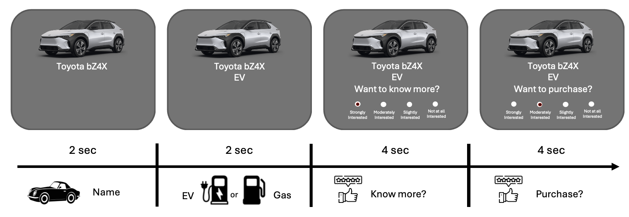
FMRI acquisition and preprocessing: Imaging data were collected on a 3T General Electric scanner equipped with a 32-channel phased-array head coil at the Stanford Center for Cognitive and Neurobiological Imaging. A high-resolution T1-weighted 3-D structural scan was initially acquired (TR=7.2 ms, TE=2.8 ms, flip angle=12°, 1 mm isotropic voxels) to serve as an anatomical reference for localizing and coregistering the subsequent functional images. Whole-brain functional images were then acquired with a T2*-weighted gradient-echo echoplanar sequence (TR=2.0 s, TE=24 ms, flip angle=77°). Forty-six interleaved axial slices (2.9 mm cubic, no gap) spanned from the mid-pons to the vertex, affording full-brain coverage and visualization of subcortical regions (e.g., NAcc). Scanning acquisition parameters were optimized to visualize subcortical activity (Srirangarajan et al., 2021).
For preprocessing, all imaging data were pre-processed using Analysis of Functional NeuroImages (AFNI) software (Cox, 1996). Slice-timing differences were corrected via sinc interpolation, and runs were concatenated before six-parameter rigid-body motion correction. For each individual, a functional volume from the start of the session was coregistered to their T1-weighted anatomical image with FSL’s FLIRT algorithm using a 6-degree-of-freedom (rigid-body) transform. The anatomical image was subsequently aligned to the MNI-152 template with a 12-degree-of-freedom affine transform (FLIRT), and the resulting combined transformation matrix was applied to the functional data, placing all volumes directly into 2 mm isotropic Montreal Neurological Institute (MNI) space (Smith et al., 2004). Coregistration outputs were visually inspected to confirm accurate alignment. Volumes were then spatially smoothed with a 4 mm full-width at half maximum Gaussian kernel to minimize anatomical variability between individuals, high-pass filtered to retain frequencies with periods ≤ 90 s and converted to percent signal-change relative to each voxel’s mean across the entire task.
Volume Of Interest (VOI) analyses targeted bilateral Nucleus Accumbens (NAcc), Anterior Insula (AIns), and Medial Prefrontal Cortex (MPFC) coordinates specified by the Affect–Integration–Motivation (AIM) framework and prior neuroforecasting research (Samanez-Larkin & Knutson, 2015). Specifically, spherical VOIs (8 mm diameter) were centered on peak value-processing foci for each structure (NAcc: [MNI: x=±12, y=12, z=–7], AIns: [MNI: x=±37, y=−18, z=−5], MPFC: [MNI: x=±6, y=49, z=–8]). Percent signal-change time series were extracted from each VOI and lagged by 4 s to accommodate for a hemodynamic delay to peak response. For each VOI, voxel-wise activity was averaged within each volume and across hemispheres to generate bilateral activity time series. Volumes with values exceeding ±3 SD from the VOI’s mean were classified as outliers and excluded from analyses.
Whole-brain verification analyses were conducted in AFNI using voxel-wise multiple regression using functional data normalized to the MNI-152 template. Each individual’s design matrix contained eleven nuisance regressors including six rigid-body motion parameters, two physiological noise estimates derived from cerebrospinal fluid and white-matter masks (Chang & Glover, 2009), and four indicator functions marking each trial phase (i.e., vehicle presentation, powertrain presentation, and the two rating prompts). To isolate task-related activity, orthogonal regressors of interest generated created for two sets of contrasts. The individual choice prediction regressor contrasted trials in which participants subsequently expressed interest in knowing more about the vehicle or not as well as interest in purchasing the vehicle or not. The second aggregate forecast regressor took a continuous parametric form representing the raw aggregate-market slope for each vehicle (formula described below). All task regressors were convolved with a single gamma hemodynamic response function (Cohen, 1997, p. 199). Individual-level contrast and parametric coefficients for each regressor were converted to Z-scores. Group statistical maps were then clustered with at least 4 contiguous 3-mm cubic voxels and thresholded (voxel-wise at p<0.05 for the 2022 sample, and p<0.005 for the 2023 sample, uncorrected for visualization purposes).

Predicting individual choice: During scanning, individuals rated their desire to know more about and to purchase each vehicle (using four spatially counterbalanced verbal options: “strongly interested,” “moderately interested,” “slightly interested,” and “not at all interested”). For prediction analyses, these ratings were dichotomized, such that “strongly” and “moderately” interested were coded as “Yes” (interested), whereas “slightly” and “not at all” interested were coded as “No” (not interested). Trial-level predictors included stimulus attributes—powertrain (electric vs. gas) and body color (black vs. white), and FMRI activity extracted from the AIM Framework VOIs. Activity time series were extracted from each VOI and shifted by 4 s to accommodate for a hemodynamic lag. Hierarchical mixed-effects logistic regression models with random intercepts for individuals were estimated as (i) a car model (Interest ~ Powertrain + Color + (1|Participant)), (ii) a brain model (Interest ~ NAcc + MPFC + AIns + (1|Participant)), and (iii) a combined model that containing both sets of predictors (Interest ~ Powertrain + Color + NAcc + MPFC + AIns + (1|Participant)). Each model tested whether its terms could predict trial-by-trial binary individual choices to “know more about” or “purchase” a vehicle (Knutson et al., 2007).
To classify individual choices, trial-level data were randomly divided into training (80%) and testing (20%) datasets. Within the training dataset, each individual’s desire to know more (i.e., their choice of “Yes” vs “No”) was downsampled into even folds (i.e., 50%). Logistic regression classifiers were implemented with the caret package in R (Kuhn, 2008). Model selection and parameter tuning used repeated (three times) 10-fold cross-validation. Within each repeat, the training set was split into 10 folds, the model was fitted on 9 folds, and performance was assessed on the remaining fold, cycling through all folds and then repeating the entire procedure twice more. Optimized vehicle features, brain activity, and combined models were subsequently evaluated for generalization to the held out independent testing data.

Forecasting aggregate demand: Data describing units of each vehicle model sold during each quarter of years 2021, 2022, 2023, and 2024 were downloaded from a publicly available internet source (i.e., goodcarbadcar.com; final accession date April 15, 2025), and subsequently validated with data acquired from a second source (i.e., https://www.marklines.com; final accession date May 20, 2025). Quarterly sales slopes derived from the two sources were strongly correlated across vehicle models, with a Pearson correlation coefficient of r=0.62 (p=0.002) for the 2022 sample and r=0.96 (p<0.001) for the 2023 sample, suggesting convergent validity (Supplementary Figure 3). Two indices of aggregate market demand were derived for each model and year: (i) average demand, defined as the mean number of units sold across all four quarters, and (ii) demand slope, defined as the coefficient of time in a simple linear regression of quarterly sales on quarter number (Q = 1, 2, 3, 4):
$$slope = {\frac{\sum_{i=1}^{4}{(Q_{i}-\bar{Q})(S_{i}-\bar{S})}}{\sum_{i=1}^{4}{(Q_{1}-\bar{Q})^{2}}}}_{}$$
where $S_{i}$​ is the number of units sold in quarter $i$ and $Q_{i}$​ is its quarterly index, $\bar{S}$ is the mean quarterly sales, and $\bar{Q}$ is the mean of the quarterly indices. Thus, a positive slope indicated increasing quarterly sales, whereas a negative slope indicated decreasing quarterly sales during a given year. The average and slope of units sold over four quarters of each year indexed average demand and demand slope across the United States market (Hulsmann et al., 2011). In the 2022 sample, market data for two vehicle models was not available leaving k=22 vehicle models for analysis, and in the 2023 sample, one vehicle model was excluded due to being an outlier with respect to change in demand (i.e., >3 standard deviations from the mean) leaving k=29 vehicle models for analysis.
Lagged neural activity extracted from targeted VOIs (i.e., the NAcc, AIns, and MPFC) was averaged and then divided by the standard deviation for each vehicle model. Participant-level brain activity greater than ±3 SD from the sample average was excluded prior to aggregation. Extracted activity was in response to vehicle stimulus onset (i.e., 4 s lag; NAcc: TR4; AIns: TR4; MPFC: TRs 5-7). Three linear regression models were fitted to forecast the annual demand slope for each vehicle: (1) a vehicle feature model (Demand Slope ~ Powertrain + Color), (2) a brain activity model (Demand Slope ~ normalized NAcc + normalized MPFC + normalized AIns), and (3) a combined model including both sets of predictors (Demand Slope ~ Powertrain + Color + normalized NAcc + normalized MPFC + normalized AIns). Preregistered hypotheses for the 2023 sample were derived from findings from the 2022 sample (link: https://osf.io/xd9mk/).

Results
Predicting individual choice: In the 2022 sample, participants expressed interest in knowing more about an average of 49% of the vehicles and interest in purchasing an average of 36.4% of the vehicles. Similarly, in the 2023 sample, participants expressed interest in knowing more about an average of 35.7% of the vehicles and interest in purchasing an average of 23.9% of the vehicles (Supplementary Figure 4). Rated desire to know more about and to purchase vehicles were robustly correlated in each sample (2022: r = 0.65; 2023: r = 0.63; Supplementary Figure 5).
In an emailed follow-up assessment of the 2023 sample (n=59; conducted in July of 2025, approximately 2 years after scanning), 64% of participants (n=38) responded. 23% (n=16) reported having purchased a vehicle and 15% (n=9) reported having purchased a model from a brand presented in the study. Comparison of purchase ratings for the nine individuals who purchased a vehicle presented in the study indicated a higher earlier purchase rating for the purchased brand versus other presented brands (t=2.71, p<0.05), consistent with incentive alignment of ratings collected during scanning with later vehicle purchase (Supplementary Figure 6).
Hierarchical logistic regression models controlling for individual-level fixed effects tested whether vehicle features, brain activity, and their combination predicted desire to know more about and to purchase vehicles (Table 1). Electric versus gas powered vehicles elicited greater desire to know more in both samples (2022: z = 12.16, p < 0.001; 2023: z = 11.83, p < 0.001), whereas body color (black vs. white) had no significant influence (p > 0.60). Powertrain and color alone also accounted for substantial trial-by-trial variance in desire to know more in both samples (marginal R² = 0.321 in 2022 and 0.072 in 2023). Brain activity regression models revealed that NAcc activity at vehicle image onset also predicted desire to know more in both samples (2022: z = 3.33, p = 0.001; 2023: z = 3.90, p < 0.001); but AIns (2022: z = −0.10, p = 0.924; 2023: z = 0.41, p = 0.68) and MPFC (2022: z = 0.05, p = 0.962; 2023: z = 1.07, p = 0.286) activity did not. Time-course analyses confirmed that increased NAcc activity during vehicle image and powertrain presentation when participants later expressed a desire to know more in both samples, as well as greater MPFC activity during the powertrain and early rating periods during these trials in the 2023 sample (Figure 2). Combined regression models revealed that while vehicle powertrain and NAcc activity predicted desire to know more, adding brain activity to powertrain accounted for only slightly more variance (i.e., yielding a higher R² and lower AIC). Significant variables in both the vehicle feature and brain activity regression models (i.e. powertrain and NAcc) remained so in the combined regression model. Analysis of predictors of desire to purchase vehicles yielded similar but less significant patterns of findings (Supplementary Table 1).
Classification analyses further verified that regression models predicted individuals’ desire to know more about and to purchase vehicles. Using balanced 80/20 training-test splits, vehicle feature predictors (powertrain + color) achieved accuracies of 0.735 in the 2022 sample and 0.681 in the 2023 sample (both ps<0.001). Brain activity predictors (based solely on the regional activities in NAcc, MPFC, and AIns) were above chance for both samples (2022: 0.557; 2023: 0.560), but only statistically significant in the 2023 sample (likely due to a substantially larger test set, i.e., 418 vs. 108 trials). Importantly, combined vehicle features and brain activity predictors yielded the best overall performance (2022 sample: 0.736; 2023 sample: 0.682; both ps < 0.001), suggesting that brain activity could add value to vehicle features.
Whole-brain analyses contrasted brain activity during vehicle image and powertrain presentation when individuals subsequently endorsed a desire to know more versus not. Similar to VOI analyses, averaged whole brain statistical maps implicated significant clusters predicting desire to know more in the bilateral NAcc and MPFC for both the 2022 and 2023 samples (Figure 3). Together, these findings confirmed that activity in targeted VOIs (and particularly the NAcc) could predict individuals’ rated desire to know more about and to purchase vehicles while establishing the quality of the brain activity data for subsequent forecasting analyses.

Table 1: Regression models predicting individuals’ desire to know more about vehicle models with vehicle features, brain activity, and their combination.
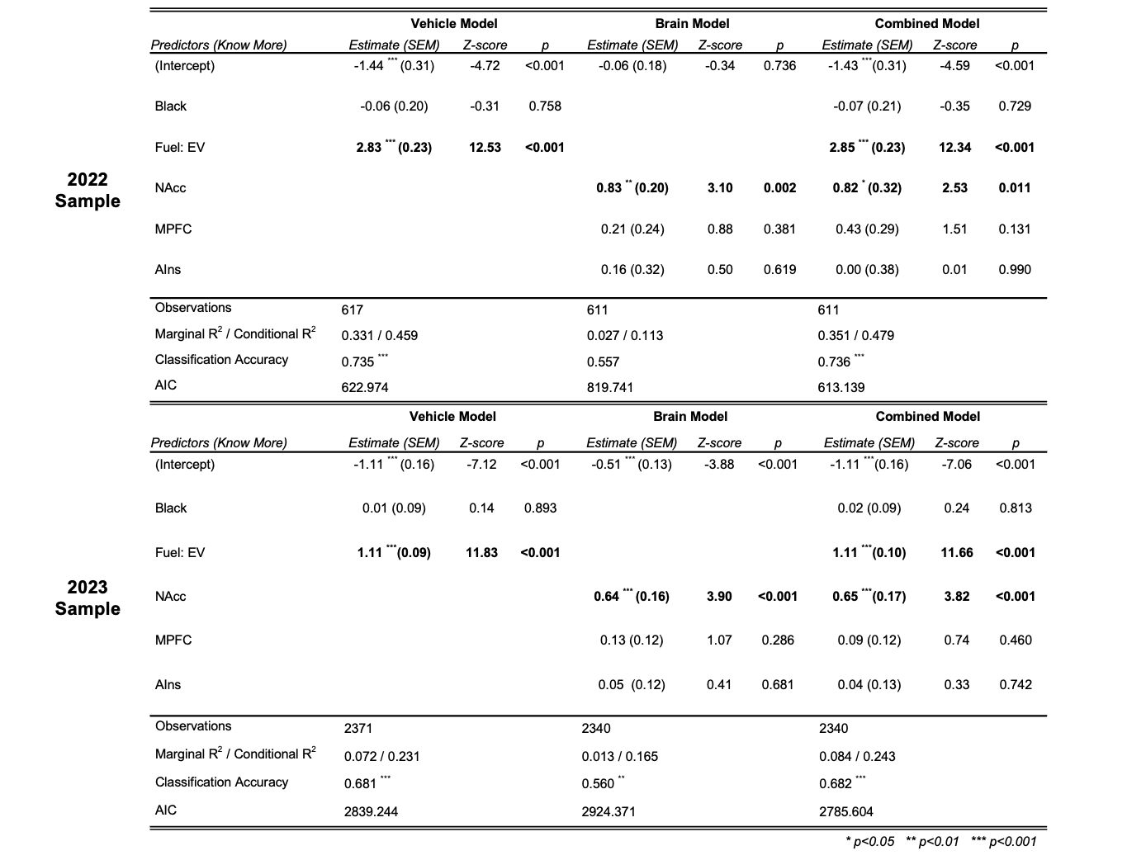
Figure 2: Brain activity predicts desire to know more about vehicles. Left plots depict the 2022 sample and right plots depict the 2023 sample.
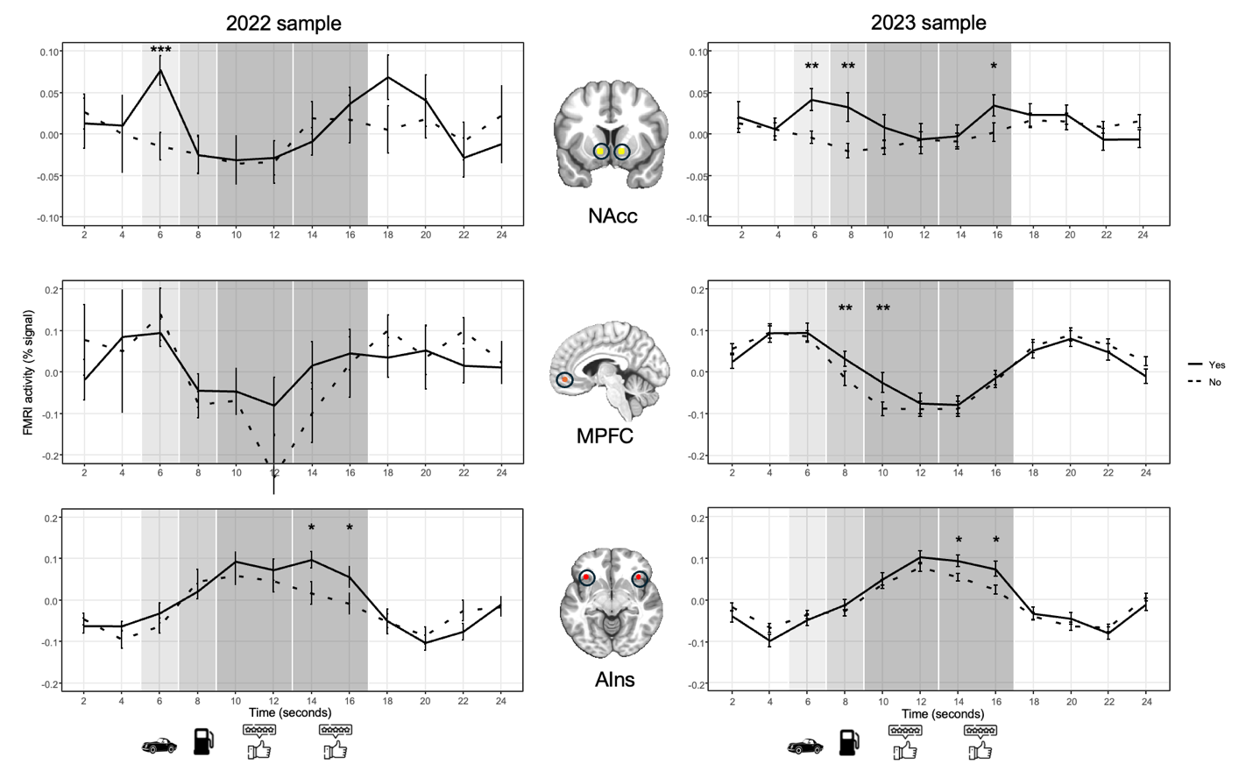

Figure 3: Whole-brain statistical maps contrasting brain activity predicting individuals’ subsequently rated desire to know more about and to purchase vehicles versus not. Warm colors are positively associated with desire to know more or purchase (vs not; p<0.01). Significant clusters appeared in bilateral striatum, including the NAcc) for both samples, as well as in the MPFC for the 2023 sample.

Forecasting changes in market demand: Linear regression models tested whether vehicle features, behavioral ratings, brain activity, and their combination forecast yearly changes in vehicle sales (Table 2). Vehicle regression models revealed that powertrain did not significantly forecast changes in market demand in 2022 (β = 456.32, p = 0.107) but did in 2023 (β = 339.69, p = 0.019). Behavior ratings regression models revealed that desire to know more did not significantly forecast demand in 2022 but marginally did in 2023 (2022: β = 281.39, p = 0.151; 2023: β = 319.12, p = 0.091). Brain activity regression models, however, revealed that normalized NAcc activity forecast positive changes in market demand in both 2022 (β = 1267.74, p = 0.002) and 2023 (β = 1300.41, p = 0.031), while MPFC and AIns activity did not (ps > 0.50). Combined models confirmed that NAcc activity remained significant in both 2022 (β = 1268.22, p = 0.006) and 2023 (β = 1231.87, p = 0.048) samples, while powertrain forecast demand only showed a similar trend in the 2023 sample (β = 368.21, p = 0.055). For 2022, the brain activity regression model performed best (R² = 0.440), while in 2023, the combined regression model performed best (R² = 0.326)(see also Supplementary Table 2). Additionally, in a confirmatory analysis that pooled vehicle‑level data across both samples, the NAcc activity forecast of changes in market demand generalized across samples (r = 0.59, p = 5.2 × 10⁻⁶), while remaining unrelated to average annual sales (r = 0.085, p = 0.36; Supplementary Figure 8). Together, these convergent findings indicated that normalized NAcc brain activity (but not vehicle features or behavioral ratings) supported the most robust forecasts of changes in market demand in 2022 as well as 2023.

Table 2: Regression models forecasting changes in aggregate market demand with vehicle features, behavioral ratings, brain activity, and their combination.

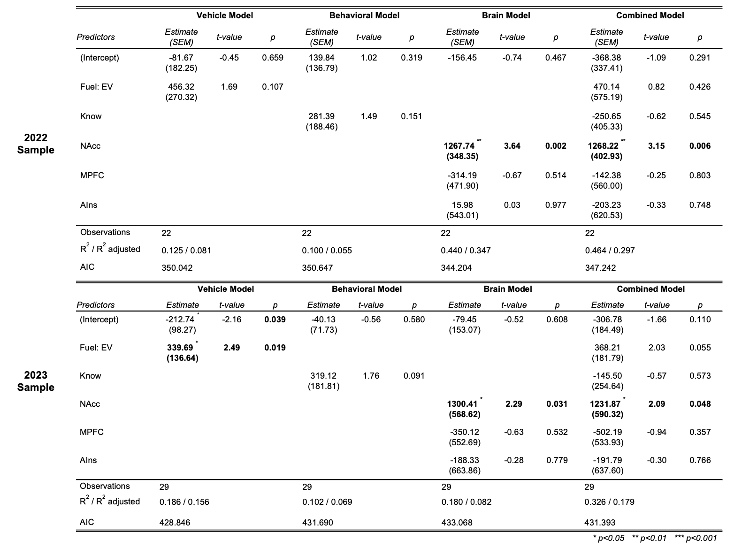

Backcasting retrospective changes in market demand. To verify the temporal specificity of forecasts, the same regression models were applied to “backcast” changes in market demand during the previous year (i.e., 2021 for the 2022 sample and 2022 for the 2023 sample). Unlike forecasting regression results, these backcasting regression models indicated that neither vehicle features nor brain activity backcast previous change in demand (Table 3). Desire to know more about vehicles, however, trended towards backcasting previous change in demand in the combined models for both 2022 (β =786.60, p = 0.083) and 2023 samples (β = 662.83, p = 0.084). These retrospective associations were more robust when desire to purchase was substituted for desire to know more in the models (Supplementary Table 3). Specifically, purchase ratings backcast previous changes in demand in both the 2022 (β = 694.3, p = 0.005) and 2023 samples (β = 552.6, p = 0.048), and these associations remained significant in the combined models (2022 sample, β = 1008.2, p = 0.044; 2023 sample, β = 751.62, p = 0.039). Together, these exploratory findings suggested that behavioral ratings were more aligned with backcasting than with forecasting changes in market demand (Figure 4).

Table 3: Regression models backcasting retrospective changes in aggregate market demand with vehicle features, behavioral ratings, brain activity, and their combination.
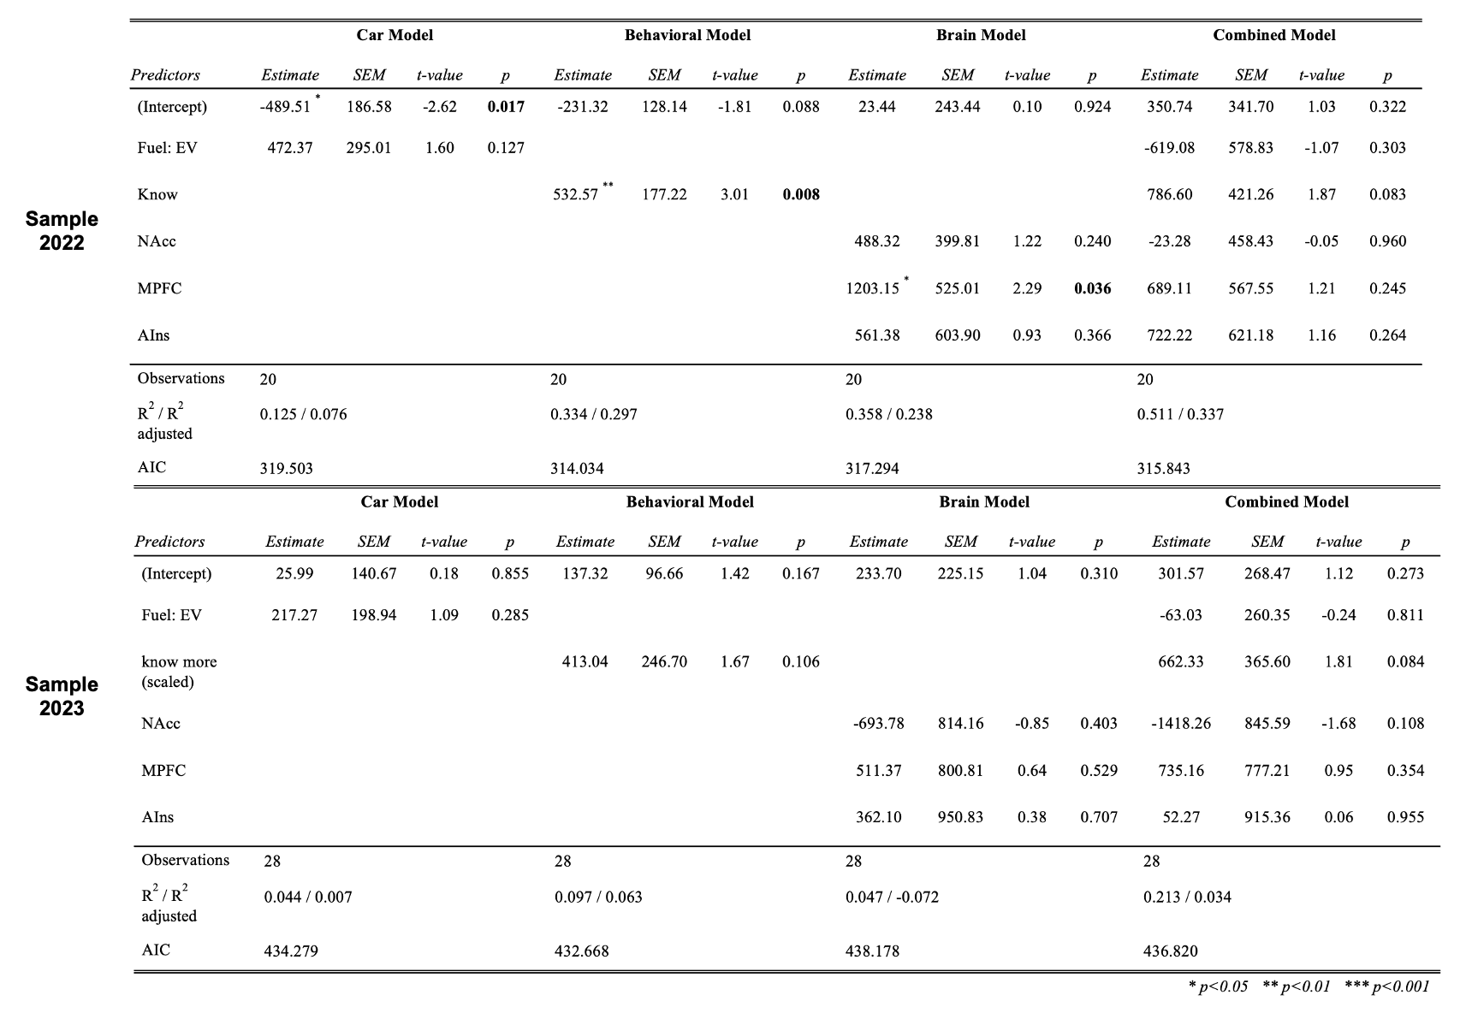

Figure 4: Behavioral ratings backcasts changes in demand (top) while brain activity forecasts changes in demand (bottom).
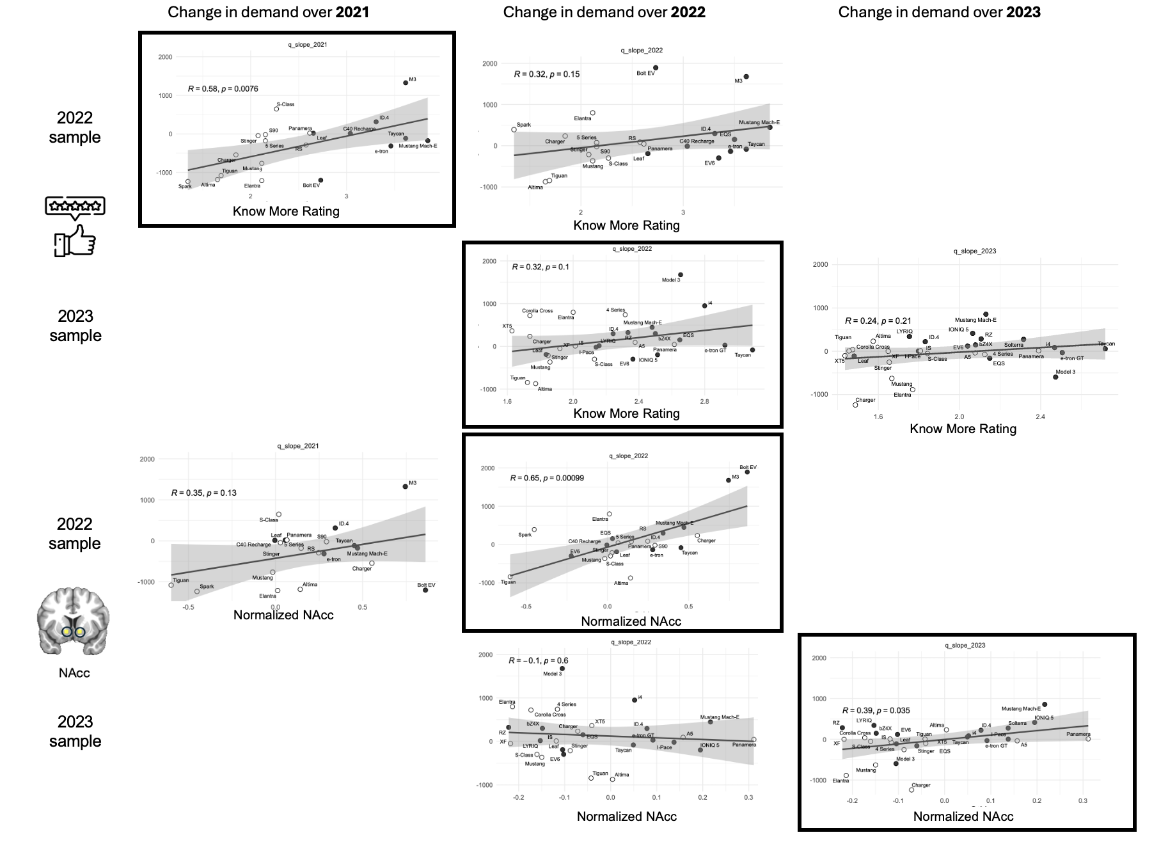

Discussion
Two studies tested not only whether brain activity could predict individual interest in purchasing vehicles with novel sustainable features, but also whether sampled brain activity could forecast changes in demand for those vehicles out-of-sample in a United States automotive market. In both samples, vehicle features and brain activity predicted individuals’ desire to know more about and to purchase vehicles. Further, brain activity (specifically in the NAcc) forecast changes in aggregate demand for vehicles, but behavioral ratings did not. These associations showed some temporal specificity, since while brain activity forecast future changes in aggregate demand for vehicles, behavioral ratings instead backcast past changes in demand for vehicles during the previous year. Together, these findings suggest that brain activity can forecast changes in demand for purchases of large products with novel features, even when behavior cannot.
This work replicates and extends previous neuroeconomic findings by verifying that brain activity in regions implicated in valuation can predict individual preferences for vehicles (Erk et al., 2002), even without overt attention or immediate choice (Tusche et al., 2010). The current findings further indicate that brain activity can predict individual preferences for significant purchases that have novel designs and features (e.g., related to sustainability such as an electric powertrain).
This work also makes new contributions to neuroforecasting research (e.g., (Knutson & Genevsky, 2018) by demonstrating that brain activity (i.e., in the NAcc) can forecast changing market demand for vehicles in the United States market. In contrast, sampled behavioral ratings did not forecast aggregate changes in demand for vehicles. These findings support the notion that brain activity in some circuits that predict individual choice may also support more generalizable forecasts than activity in other circuits or even choice behavior (Genevsky et al., 2025). Sampled behavioral ratings were associated with changes in demand during the previous year, however, while brain activity was not. Thus, the findings provide initial evidence linking sampled brain activity with forecasting, but behavioral ratings instead with backcasting.
This work includes several strengths, including direct comparison of product features and brain activity to predict individual choice of significant products with novel features (and longitudinal verification of incentive alignment). Similarly, the work supported direct comparisons of the ability of vehicle features, behavioral ratings, and brain activity to forecast changes in market demand out-of-sample. A novel aggregate measure of change in market demand further highlighted the temporal specificity of forecasts with brain activity. While the size of the 2022 sample was small, preregistered findings from the larger 2023 sample replicated the initially observed associations with adequate power (Supplementary Figure 7) -- despite involving a different sample, different vehicles, and shifts in market demand for some of the same vehicles from one year to the next (Supplementary Figures 8-9). Finally, the ability of brain activity to forecast market demand held across variable United States market conditions from 2022 to 2023. Specifically, demand for vehicles with electric powertrains was not only significant and growing, but also dynamic, since the United States market share of vehicles with electric powertrains increased from 6.8% in 2022 to 9.1% in 2023 (i.e., a 33% increase, (IEA, 2025).
This work has some necessary limitations. Because rapid phasic responses in subcortical circuits best predict individual choice and forecast market demand (Figure 2), presentation of information about the vehicles required precise synchronization with brain data acquisition and timing (consistent with previous research on purchasing, e.g., (Knutson et al., 2007). Thus, while the initial appearance of each vehicle, its name, and brand may have generated relevant brain activity, analyses cannot distinguish responses to these simultaneously-presented features. Additionally, the brief timing of each trial necessarily precluded presentation of other distinct but potentially relevant vehicle attributes (e.g., price, discounts, etc.). To investigate changes in market demand over a year, individuals were scanned during the second sales quarter of each year on average, so whether forecasting findings generalize to other time frames (e.g., at the end of the year) remains to be tested. Future research may also explore whether and how individual differences influence the contribution of brain activity to predicting individual purchases and to forecasting market demand (Genevsky et al., 2025).
Together, these findings have implications for theory as well as application. With respect to theory, the findings imply that brain activity can forecast changing demand for large purchases with novel features at the market level. Behavior, instead, was associated with backcasting previous changes in demand. This divergence suggests that distinct neuropsychological mechanisms may support forecasting versus backcasting aggregate behavior (Addis et al., 2007). Specifically, while behavioral ratings may reflect explicit retrospective evaluations informed by prior experience, neural activity may tap into more implicit responses capable of forecasting future changes in market demand. With respect to application, the added value of brain activity (in the NAcc) over and above behavior in forecasting changes in aggregate demand is consistent with the notion that some neural measures might generalize more broadly than behavior in forecasting demand for relevant products (Karmarkar & Yoon, 2016; Shaw & Bagozzi, 2018). This increased generalizability may reveal “latent demand” that has not yet translated into observable behavior at scale. In changing markets incorporating products with new features, latent demand may resist detection by retrospective ratings or past data but still appear in anticipatory brain responses (Genevsky et al., 2025). Thus, brain activity might reveal generalizable preferences before they manifest in the marketplace, with the potential to improve forecasts.

References

Addis, D. R., Wong, A. T., & Schacter, D. L. (2007). Remembering the past and imagining the future: Common and distinct neural substrates during event construction and elaboration. Neuropsychologia, 45(7), 1363–1377. https://doi.org/10.1016/j.neuropsychologia.2006.10.016
Ariely, D., & Berns, G. S. (2010). Neuromarketing: The hope and hype of neuroimaging in business. Nature Reviews Neuroscience, 11(4), 284–292. https://doi.org/10.1038/nrn2795
Armstrong, J. S., Morwitz, V. G., & Kumar, V. (2000). Sales forecasts for existing consumer products and services: Do purchase intentions contribute to accuracy? International Journal of Forecasting, 16(3), 383–397. https://doi.org/10.1016/s0169-2070(00)00058-3
Assmus, G. (1984). New product forecasting. Journal of Forecasting, 3(2), 121–138. https://doi.org/10.1002/for.3980030202
Chang, C., & Glover, G. H. (2009). Effects of model-based physiological noise correction on default mode network anti-correlations and correlations. NeuroImage, 47(4), 1448–1459. https://doi.org/10.1016/j.neuroimage.2009.05.012
Cohen, M. S. (1997). Parametric Analysis of fMRI Data Using Linear Systems Methods. NeuroImage, 6(2), 93–103. https://doi.org/10.1006/nimg.1997.0278
Cox, R. W. (1996). AFNI: Software for Analysis and Visualization of Functional Magnetic Resonance Neuroimages. Computers and Biomedical Research, 29(3), 162–173. https://doi.org/10.1006/cbmr.1996.0014
Dunlap, R. E., Van Liere, K. D., Mertig, A. G., & Jones, R. E. (2000). New Trends in Measuring Environmental Attitudes: Measuring Endorsement of the New Ecological Paradigm: A Revised NEP Scale. Journal of Social Issues, 56(3), 425–442. https://doi.org/10.1111/0022-4537.00176
Ebert, J. E. J., Gilbert, D. T., & Wilson, T. D. (2009). Forecasting and Backcasting: Predicting the Impact of Events on the Future. Journal of Consumer Research, 36(3), 353–366. https://doi.org/10.1086/598793
Erk, S., Spitzer, M., Wunderlich, A. P., Galley, L., & Walter, H. (2002). Cultural objects modulate reward circuitry. NeuroReport, 13(18), 2499–2503. https://doi.org/10.1097/00001756-200212200-00024
Genevsky, A., Tong, L. C., & Knutson, B. (2025). Neuroforecasting reveals generalizable components of choice. PNAS Nexus, 4(2). https://doi.org/10.1093/pnasnexus/pgaf029
Goodwin, P., Meeran, S., & Dyussekeneva, K. (2014). The challenges of pre-launch forecasting of adoption time series for new durable products. International Journal of Forecasting, 30(4), 1082–1097. https://doi.org/10.1016/j.ijforecast.2014.08.009
Gosling, S. D., Rentfrow, P. J., & Swann, W. B. (2003). A very brief measure of the Big-Five personality domains. Journal of Research in Personality, 37(6), 504–528. https://doi.org/10.1016/s0092-6566(03)00046-1
Hulsmann, M., Borscheid, D., & Friedrich, C. M. (2011). General sales forecast models for automobile markets and their analysis. In Advances in Data Mining: Applications and Theoretical Aspects (pp. 255–269). Springer.
Karmarkar, U. R., & Yoon, C. (2016). Consumer neuroscience: Advances in understanding consumer psychology. Current Opinion in Psychology, 10, 160–165. https://doi.org/10.1016/j.copsyc.2016.01.010
Knutson, B., & Genevsky, A. (2018). Neuroforecasting Aggregate Choice. Current Directions in Psychological Science, 27(2), 110–115. https://doi.org/10.1177/0963721417737877
Knutson, B., Rick, S., Wimmer, G. E., Prelec, D., & Loewenstein, G. (2007). Neural Predictors of Purchases. Neuron, 53(1), 147–156. https://doi.org/10.1016/j.neuron.2006.11.010
Kuhn, M. (2008). Building Predictive Models inRUsing thecaretPackage. Journal of Statistical Software, 28(5). https://doi.org/10.18637/jss.v028.i05
Levy, D. J., & Glimcher, P. W. (2012). The root of all value: A neural common currency for choice. Current Opinion in Neurobiology, 22(6), 1027–1038. https://doi.org/10.1016/j.conb.2012.06.001
Morrison, D. G. (1979). Purchase Intentions and Purchase Behavior. Journal of Marketing, 43, 65–74.
Morwitz, V. G., Steckel, J. H., & Gupta, A. (2007). When do purchase intentions predict sales? International Journal of Forecasting, 23(3), 347–364. https://doi.org/10.1016/j.ijforecast.2007.05.015
Robinson, J. B. (1982). Energy backcasting A proposed method of policy analysis. Energy Policy, 10(4), 337–344. https://doi.org/10.1016/0301-4215(82)90048-9
Samanez-Larkin, G. R., & Knutson, B. (2015). Decision making in the ageing brain: Changes in affective and motivational circuits. Nature Reviews Neuroscience, 16(5), 278–289. https://doi.org/10.1038/nrn3917
Shaw, S. D., & Bagozzi, R. P. (2018). The neuropsychology of consumer behavior and marketing. Consumer Psychology Review, 1(1), 22–40. https://doi.org/10.1002/arcp.1006
Smith, S. M., Jenkinson, M., Woolrich, M. W., Beckmann, C. F., Behrens, T. E. J., Johansen-Berg, H., Bannister, P. R., De Luca, M., Drobnjak, I., Flitney, D. E., Niazy, R. K., Saunders, J., Vickers, J., Zhang, Y., De Stefano, N., Brady, J. M., & Matthews, P. M. (2004). Advances in functional and structural MR image analysis and implementation as FSL. NeuroImage, 23, S208–S219. https://doi.org/10.1016/j.neuroimage.2004.07.051
Srirangarajan, T., Mortazavi, L., Bortolini, T., Moll, J., & Knutson, B. (2021). Multi‐band FMRI compromises detection of mesolimbic reward responses. NeuroImage, 244, 118617. https://doi.org/10.1016/j.neuroimage.2021.118617
Tusche, A., Bode, S., & Haynes, J.-D. (2010). Neural Responses to Unattended Products Predict Later Consumer Choices. Journal of Neuroscience, 30(23), 8024–8031. https://doi.org/10.1523/jneurosci.0064-10.2010

